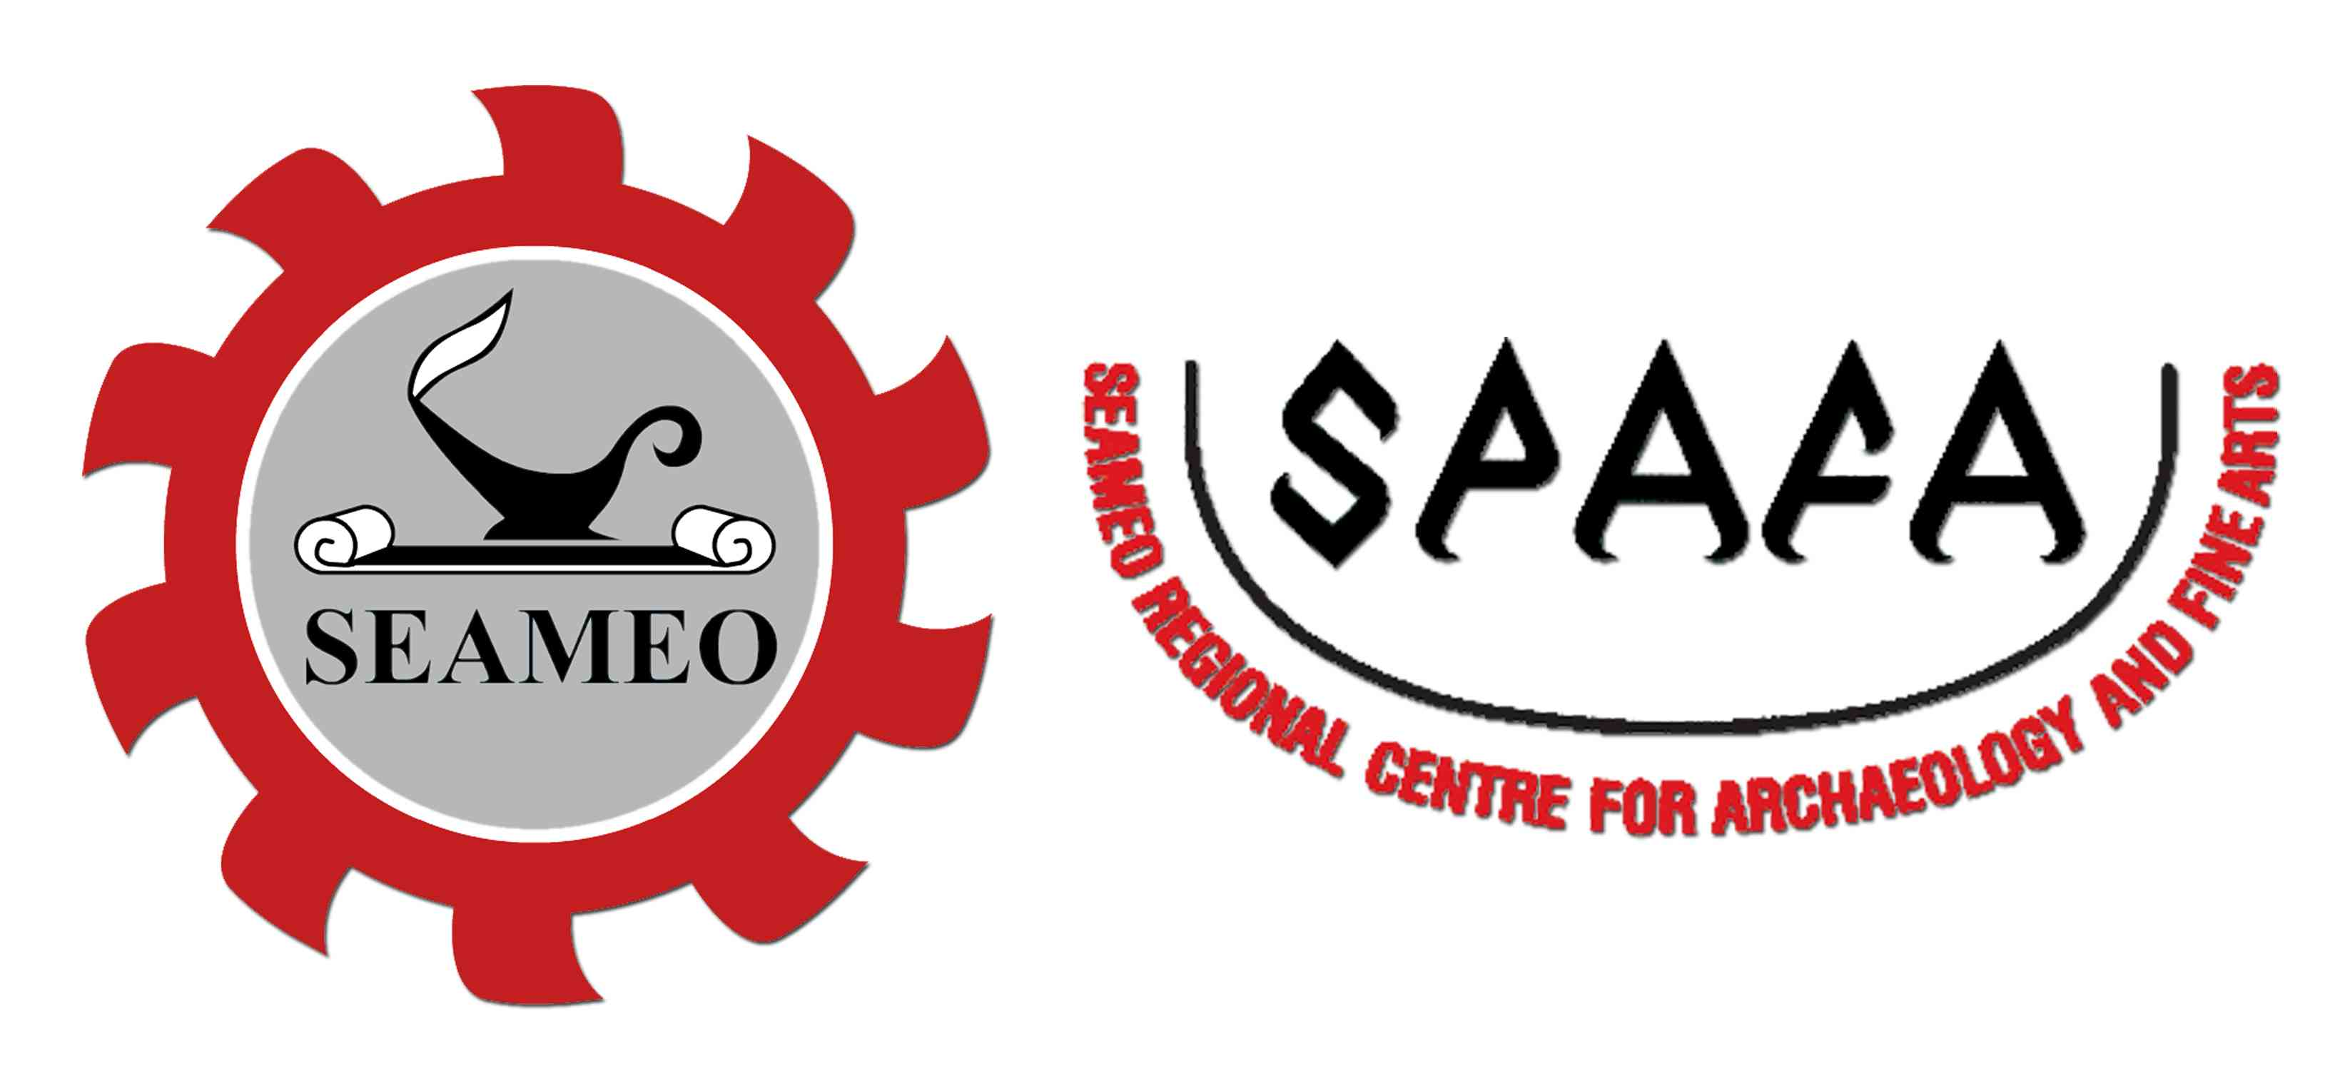
SOUTHEAST ASIAN MINISTERS OF EDUCATION ORGANIZATION
SEAMEO REGIONAL CENTRE FOR ARCHAEOLOGY AND FINE ARTS
Seminar and Performances of a Shared Heritage:
The Panji/Inao Traditions in Southeast Asia
2 - 6 March 2013,
Seminar: Bangkok Cha-Da Hotel
Performances: Thailand Cultural Centre
Bangkok, Thailand
__________________________________________________________________
REGISTRATION FORM
1. Name (Prof./Dr./Mr./Ms):__________________________________________________
2. Position:________________________________________________________________
3. Organization/Institution:____________________________________________________
4. Contact Address:__________________________________________________________
________________________________________________________________________
________________________________________________________________________
Tel. no.______________________________ Fax.no._____________________________
E-mail:__________________________________________________________________
5. I would like to attend:
[ ] Seminar on 2-3 March 2013
[ ] Performances
[ ] 4 March 2013
[ ] 5 March 2013
[ ] 6 March 2013
Advance registration required for free seminar. No entrance fees for performances.
Please complete this form and return it to SEAMEO SPAFA by fax.02-280-4030
or email: spafa@seameo-spafa.org, preferably no later than 27 February 2013

